Digital Literacy

Submitted by: AARYESH RAHUL THORAT
Registration Number: 25MIP10076

Project Task

Task- 3 – Platforms

Task 3 Platforms
Create an account on HackerRank
& solve one beginner problem

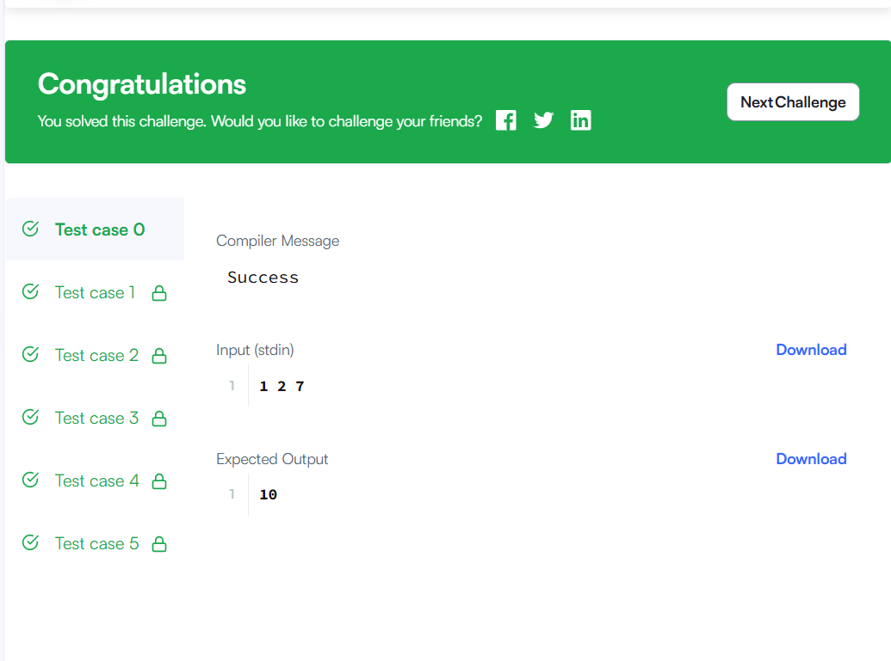

Google Workspace
Google Form
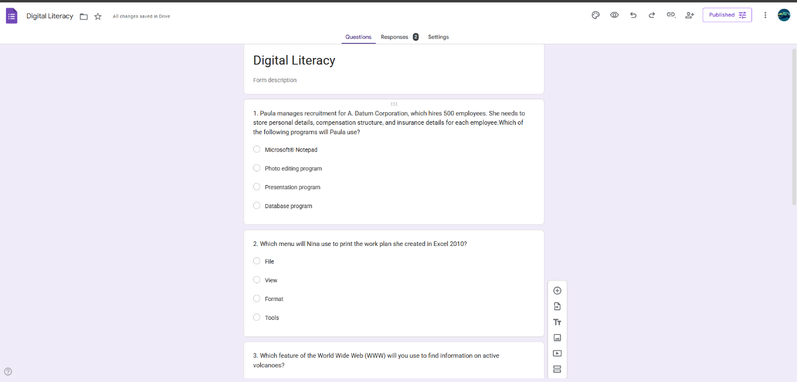

Response

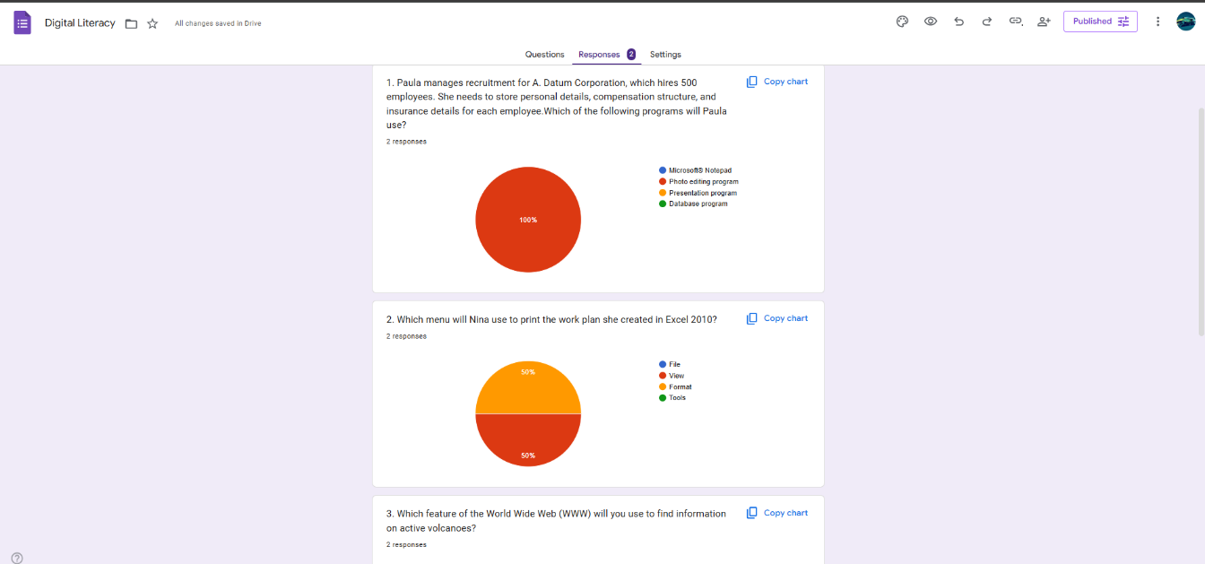

Reflection Report on HackerRank & Google Form
For this task, I explored two useful digital platforms: HackerRank and Google Forms. HackerRank is a coding practice platform that helps students improve their programming and problem-solving skills. I created an account and completed a beginner-level challenge. This experience helped me understand how coding platforms provide structured problems along with instant feedback, which makes it easier to learn programming concepts and prepare for technical interviews.
I also created a Google Form to design a Digital Literacy Awareness Quiz with five questions. The quiz included different types of questions, such as multiple-choice and short-answer questions. Google Forms is a convenient tool for collecting information and automatically organizing responses in a spreadsheet. It is widely used for surveys, quizzes, and feedback collection.
Through this activity, I realized how digital platforms can support both technical learning and collaboration. These tools will help me practice coding regularly and create simple digital solutions for academic tasks.

